JavaScript

=> Variables:

1: const : we can not change the value .
2: var : prefer not use var because of issue in block scope and functional scope.
3: let : we use it mostly because of solved issue of var.

“use strict ” : treat all js code as newer version.

=> DataTypes

=> Premetve Datatype

number => 2 to power 53 // range ha ham is range tak number store kerwa sakty ha ager zayda kerwany ho tu phir bigint ka use kerty hain
string = ””
boolean => true/false
null => standalone value
undefined =>
symbol => uniqueness (mostly use in react use when we want to find uniqueness in react components)

=> Non premetive Datatype

typeof
console.log(typeof null);

output :
object

console.log(typeof undefined);

output:
undefined
=> Conversion Operation

“33” => 33
“33abc” => NaN
undefined => undefined
true => 1; false=> 0
1 => true; 0 =>false
“huzaifa” => true
“ ” => false
null => 0 when we convert in number
null => null without converting it

=> console.log(“1” +2); output : 12
=> console.log(1+ “2”); output : 12
=> console.log(“1” + 2 + 2);output : 122 (ager pehly string hoga tu sab ko string ki terha treat kery ga)
=> console.log(1 + 2 + “2”); output : 32 (ager number hoga tu as number treat kryga)

=> console.log(+true); output : 1
=> console.log(+””); output : 0

=> incremental operator prefix(++x) and postfix(x++)

++(++x) // syntaxError :Invelid Left-hand side expression in prefix operation.

=> postfix increment
let x = 3;
const y = x++;

console.log(`x:${x}, y:${y}`);
// Expected output: "x:4, y:3"

=> prefix increment
let a = 3;
const b = ++a;

console.log(`a:${a}, b:${b}`);
console.log(undefined <0)
output : false

console.log(undefined==0)
output : false

console.log(undefined > 0)
output : false

console.log(undefined === o)
output : false

// stright check === it check the data type

console.log(“2” === 2)
output : false

=> Primitive DataTypes => ( ya call by values ) : call by value ka matlab ha k jab b inki value ki need hoti ha tu ham copy kr k use krty hain or actual value wahi rehti ha:

=> 7 types

1) String
2) Number
3) Boolean
4) null (null ka matlab empty hota ha not empty string ak dam khali hota ha)
5) undefined ( iska memory me khali space hota ha lakin value undefined hoti ha or value ka nhi pta hota k value kia ha)
6) symbol (kisi b value ko unique banay k leeya use hoti ha)
7) BigInt (use for large value)

=> Non-Primitive (call by reference) : call by reference ka matlab in ki values ka memory reference directly hamy allocate / (day dia jata ha) kia jata ha :

1) Array
2) Object
3) Functions

const score=100
const scoreValue=100.3
console.log(typeof scoreValue)
output : number

both are number not float and nor int

const isLoggedIn=false;

// boolean type

=> How to declare Symbol?

Const id = Symbol(‘123’)
const anotherId = Symbol(‘123’)
console.log(typeof id)
console.log(id ===anotherId)

output :
false => both arte not same
symbol

=> BitInt

const bigNumber =3456535766394565204903849957n

console.log(typeof bigNumber);
output : bigint

=> Why we Called Array , Object , Function as a Non-primitive
let we check and understand

const heros=[“Huzaifa” , “Basit” ,”Miraj”] // Array (ya reference type ha)

{
//Object (ham isko kisi variable me b store kr sakty hain or is ka andar DataTypr kuch b hosakta ha number b hoska ha String b hosakta ha )

name : “GhulamAli” // String Datatype
age:22 // number Datatype
}

OR

let myObj={
name: “AbdulRehman” //String
age : 13 // Number
}

=> How to treat Function like variable
let see

const myFunction =function(){
console.log(“Hello Wors”)
}

console.log(typeof myFunction)
output : function // function hamasha function he return krta ha isko object Function kehty hain

=> comparison operator

console.log(null > 0);
console.log(null == 0);
console.log(null >= 0);
console.log(undefined == 0);
console.log(undefined > 0);
console.log(undefined < 0);

Output:
true
true
false
false
true

=> Memory
Q1. How memory works in JavaScript?

Stack And Heap
primitive datatype : (Stack) me values ko store kerty ha (copy of value milti ha)

Non-Primitive datatype: (Heap) me values ko store kerty ha(reference milta ha original value ka jo b chang krain jo b value change kernay say original value me chang hoga)

Example:

let myYoutubeName= “huzaifaAliKamboh” //stack me store hoga
let anothername=myYoutubeName;
anothername=”basit”
console.log(myYoutubName)
console.log(anothername)

output:
huzaifaAliKamboh
basit

basit
huzaifaAliKamboh
Stack
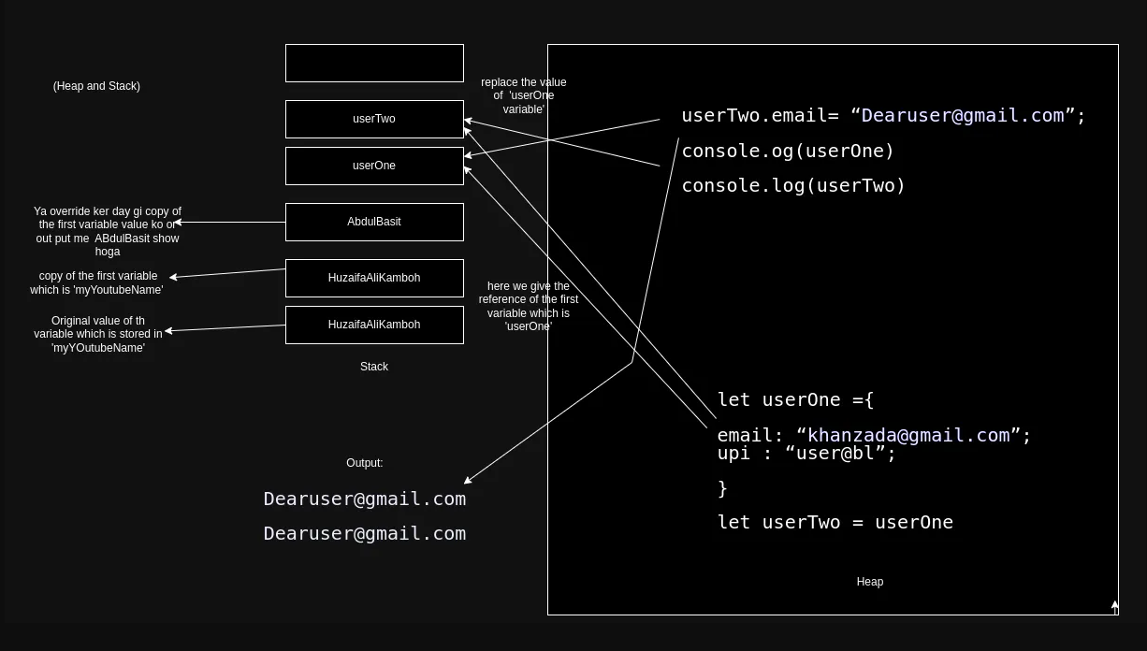
let user={
email: ”huzaifakamboh102@gmail.com”
upi: “user@bl”
}
user
basit
huzaifaAliKamboh
Stack
{

email: ”huzaifakamboh102@gmail.com”
upi: “user@bl”

}
Heap

heap: call by reference change in original value
stack: call by value change in copy of the value

let userTwo = user
userTwo.email= “khan@gmail.com”
console.log(user)
console.log(userTwo)

output:
huzaifakamboh102@gmail.com
khan@gmail.com

=> String:
“hello”+”world”
output:
helloworls

const name = ”huzaifa”
const repoCount= 50
console.log(name+repoCount+”value of my etc”)
//it is worst to use it is not a better way to write code like this

we can write like because it ismodern way result are same this method called ‘string interpulation’

console.log(`hello my name is ${name} and my repo count is ${repoCount}`) ;

output:

huzaifa 50 value of my etc
hello my name is huzaifa and my repo count is 50

=> Another way to declare string

const gameName=new String(`huzaifa`) →→// here string is a object

console.log(gameName[0])
console.log(gameName.__proto__)

output
h
{} → → it is not empty it has a lot of methods

// we can use a lot of mrthod for string for example:
console.log(gameName.length)
console.log(gameName.topperCase())→ → it change the string into upper Case but not change the original string value
console.log(gameName.charAt(2) → → output: u character by using index
console.log(gameName.indexOf(‘u’)); → → output: 2 character by using character

=> method to break String into parts

const newString = gameName.substring(0,4)
console.log(newString);

output:
huza

const anotherString-gameName.slice(-8,4)
console.log(anotherString)

output:
ifa // because it start from end or revers

=> trim()

const newStringOne =” huzaifa ”
console.log(newStringOne.trim());

output:
huzaifa // it remove the extra spaces

=> replace()
const url = “https://huzaifa.com/huzaifa%20kamboh”
console.log(url.replace(`%20`,`-`)
output:
https://huzaifa.com/huzaifa-kamboh

=> includes() //it check either keyword is match with given keyword

console.log(url.include(‘basit’))

output:
false

=> split()
=> small()

=> Number and Maths

const score = 40
console.log(score)
OR
const balance = new Number(100)
console.log(balance.toString().length);

output:
40
3

=> toFixed()

console.log(balance.toFixed(2));

output:
100.00

=> toPrecision()
const otherNumber = 123.8966
console.log(otherNumber.toPrcision(3));
3 point say pehly ki value k bad ki values ko roundof kery ga

output:
124

const otherNumber = 1123.8966
console.log(otherNumber.toPrcision(3));

output:
1.12e+3 // ya exponent me value return kr rha ha q k ham nay precision sahi use nhi kia hamy precision me value 4 deni thi lakin teen 3 de ha .

=>toLocalString()

const hundreda = 1000000
console.log(hundreds.toLocalString(‘en-IN’));

output:
10,00,000
// ya indian standard me values me comma lagty hain lakin ham kisi b country k standard me ker sakty ha

